MANIPULATING DATA

1. Create EmpTest from Emp table by copying structure and data.
SQL> CREATE TABLE EmpTest11 AS SELECT * FROM Emp;
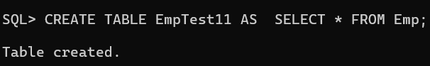
- Add a new row into the EmpTest table for Empno,Ename,Sal columns. In Ename should have the Current User.
SQL> INSERT INTO EmpTest 11(Empno, Ename, Sal) VALUES (1234, 'Sowmya', 5000);
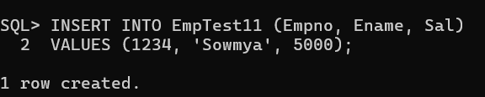
- Update EmpTest by increasing the Salary of TURNER by 15%. Confirm your changes.
SQL> UPDATE EmpTest11
SET Sal = Sal* 1.15
WHERE Ename = 'TURNER';
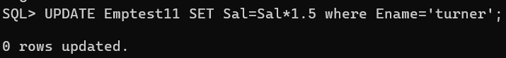
SQL> SELECT * FROM EmpTest11
WHERE Ename=’TURNER’; 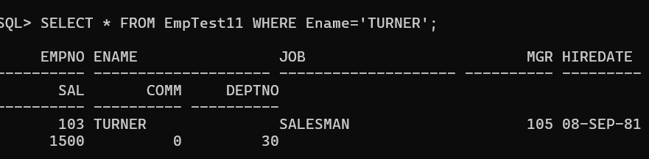
- Update the salary of Smith with salary of Scott using EmpTest table.
SQL> UPDATE EmpTest SET Salary = (SELECT Salary FROM EmpTest
WHERE Ename = 'SCOTT') WHERE Ename = 'SMITH';
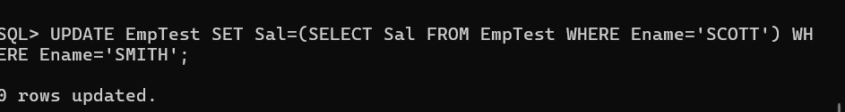
- Increase all the employees salary by 10% in EmpTest table who are working in NEW YORK.
SQL> UPDATE EmpTest11 SET Sal= Sal* 1.10 WHERE Deptno IN
( SELECT Deptno FROM Dept WHERE Loc='NEW YORK' );
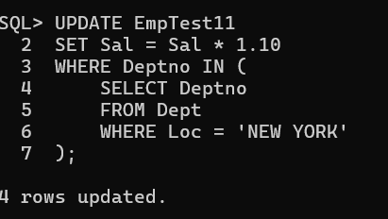
- Delete all the Comm data from EmpTest Table;
SQL>UPDATE EmpTest SET Comm = NULL;
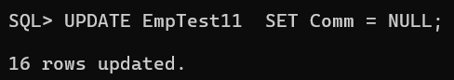
- Delete all the employees from EmpTest table who are working in SALES dept.
SQL> DELETE FROM EmpTest WHERE Deptno =
( SELECT Deptno
FROM Dept
WHERE Dname='SALES'
);

- Delete all the who are working with that employee, except that Employee.(Prompt for the ENAME).
SQL> DELETE FROM EmpTest
WHERE Deptno =
(SELECT Deptno
FROM EmpTest
WHERE Ename='&ENAME') AND Ename<>'&ENAME';
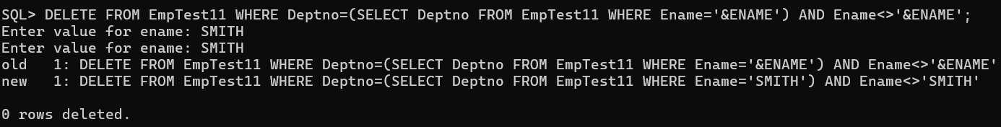
- Create Emp2 from Emp by only copying Empno,Ename,sal without copying data.
SQL> CREATE TABLE Emp2 AS
SELECT Empno,Ename,Sal
FROM Emp
WHERE 1=2;
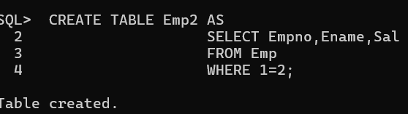
- Create Emp3 from Emp by only copying Empno,Job without copying data.
SQL> CREATE TABLE Emp3 AS
SELECT Empno,Job
FROM Emp
WHERE 1=2;
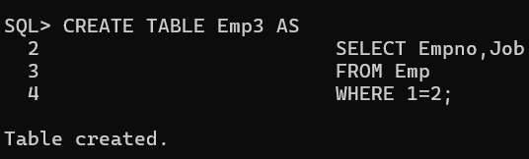
- Using multitable insert Emp data into Emp2 and Emp3 Tables.
SQL> INSERT ALL
INTO Emp2(Empno,Ename,Sal)
VALUES(Empno,Ename,Sal)
INTO Emp3(Empno,Job)
VALUES(Empno,Job)
SELECT Empno,Ename,Sal,Job
FROM Emp;
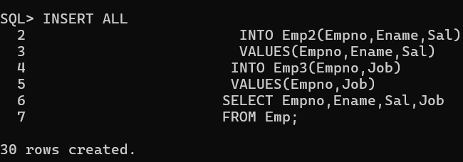
- Truncate Emp2 Table and insert following two rows as follows: 7788, SMITH, 4500 /7654, JACK, 3500.
SQL> TRUNCATE TABLE Emp2;
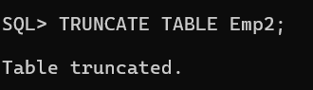
SQL>INSERT INTO Emp2 VALUES(7788,'SMITH',4500);
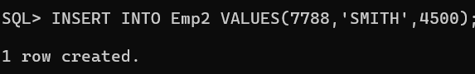
SQL>INSERT INTO Emp2 VALUES(7654,'JACK',3500);
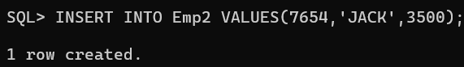
- Commit the Data.

SQL>commit;


- Using Merge statement insert and update Emp2 using Emp.
SQL> MERGE INTO Emp2 E2
USING Emp E
ON (E2.Empno=E.Empno)
WHEN MATCHED THEN
UPDATE SET
E2.Ename=E.Ename,
E2.Sal=E.Sal
WHEN NOT MATCHED THEN
INSERT(Empno,Ename,Sal)
VALUES(E.Empno,E.Ename,E.Sal);
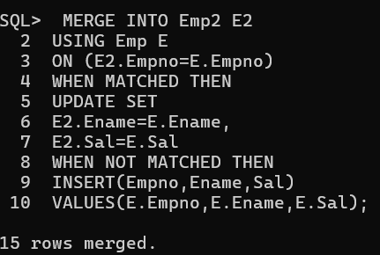
- Verify your changes.
SQL>select * from emp2;
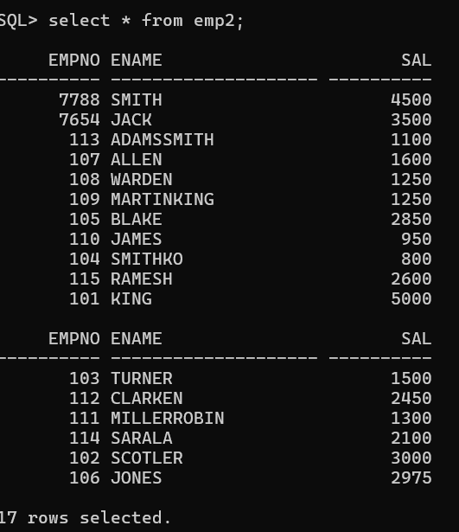

- Rollback the Data.
SQL>rollback;
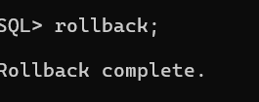
17.Using Merge statements update Emp2 table for only Empno=7788 and Insert only those employees whose salary is more than 3000.
SQL> MERGE INTO Emp2 E2
USING
(
SELECT *
FROM Emp
WHERE Sal>3000
) E
ON(E2.Empno=E.Empno)
WHEN MATCHED THEN
UPDATE SET
E2.Ename=E.Ename,
E2.Sal=E.Sal
WHERE E.Empno=7788
WHEN NOT MATCHED THEN
INSERT(Empno,Ename,Sal)
VALUES(E.Empno,E.Ename,E.Sal);
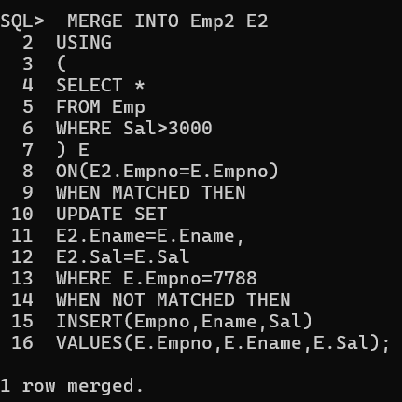
18.Verify your changes.
SQL>select * from emp2;
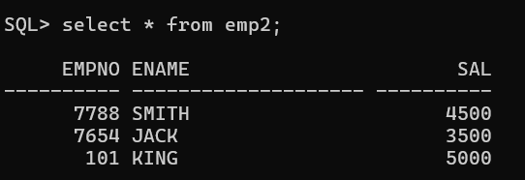

19.Create a User WIPRO.
SQL> CREATE USER WIPRO IDENTIFIED BY wipro;
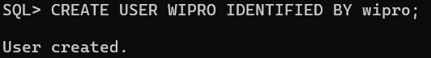
SQL> GRANT CONNECT, RESOURCE TO WIPRO;
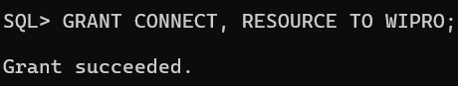
20. Grant ALL permission on EMP table from SCOTT to WIPRO user.
SQL> GRANT ALL ON Emp TO WIPRO;
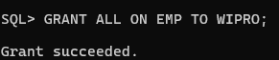
21. Delete all the employees in deptno 10 and do not issue a Commit.
SQL> DELETE FROM Emp WHERE Deptno=10;
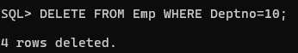
22.From WIPRO user delete all the employees from SCOTT.EMP table in DEPTNO=10. What happens and Why?
SQL>DELETE FROM Scott.Emp WHERE Deptno=10;
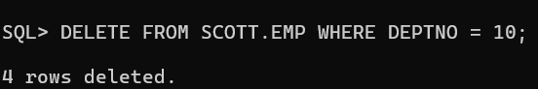
23. Issue a Rollback in SCOTT user and Check the WIPRO user.
SQL> ROLLBACK;
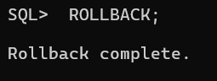
SQL> SELECT * FROM Scott.Emp WHERE Deptno=10; 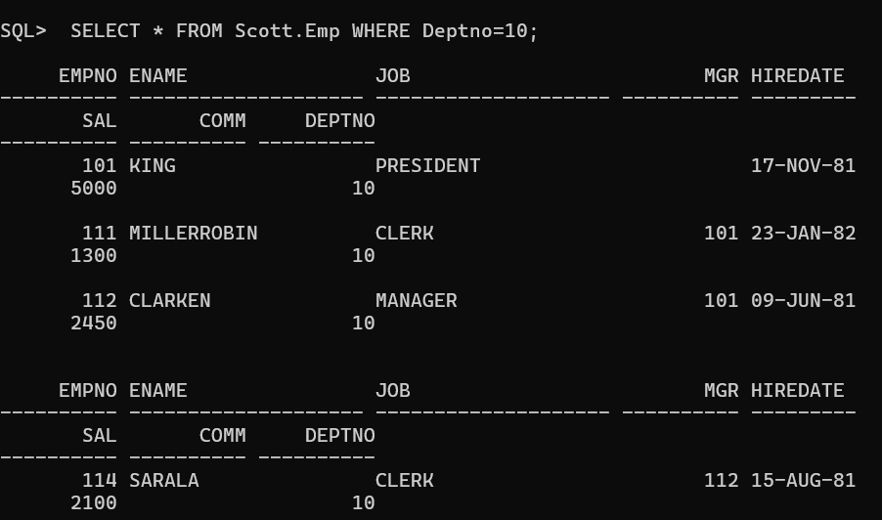
24.In SCOTT user give a query on EMP using FOR UPDATE clause with WAIT 20 seconds? What happens?
SQL> SELECT * FROM Emp FOR UPDATE WAIT 20;
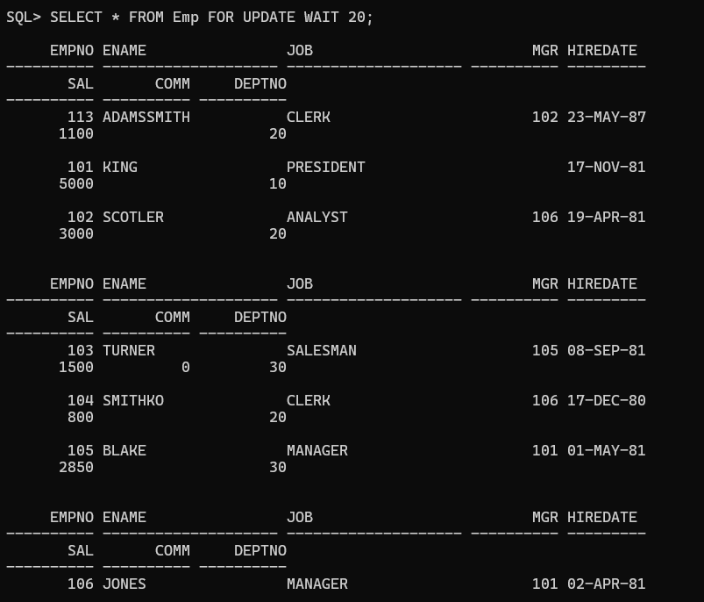
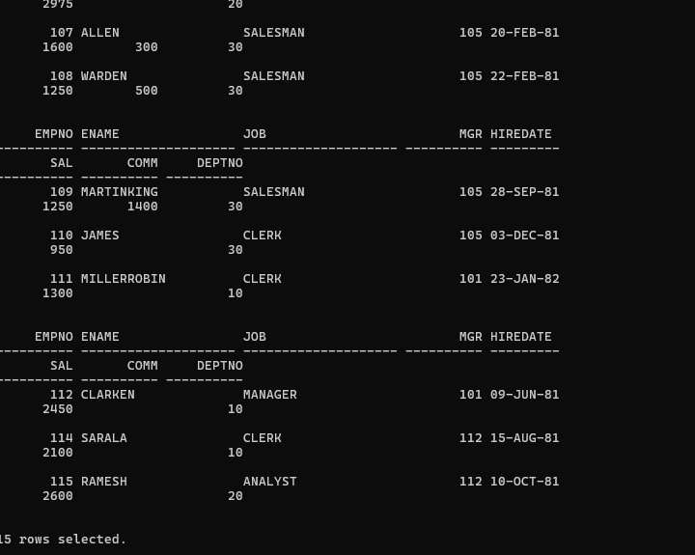
25.In WIPRO User issue a ROLLBACK and now check in SCOTT user.
SQL>rollback;

26. ROLLBACK all the transactions in SCOTT and WIPRO Users.
SQL>rollback;


